Shubham Rawat
MCA 2020 -2022
OS Assignment 1

1.
mkdir Shubham

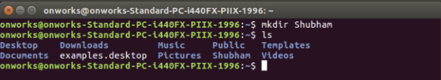

2.
touch Shubham.txt
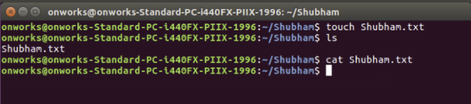
3.

vi Shubham.txt or cat > Shubham.txt

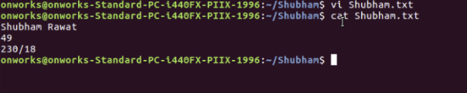
4.
cat Shubham.txt

5.
mv /home/onworks/Shubham/Shubham.txt /home/onworks/Shubham2

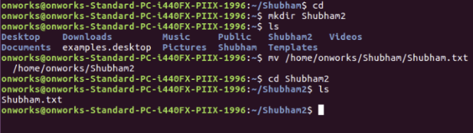
6.
mv Shubham.txt ShubhamRawat.txt

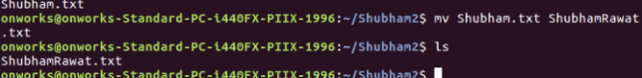
7.
cat ShubhamRawat.txt > CopyShubham.txt

